Oxfordshire’s Homelessness and Rough Sleeping Strategy Refresh 2026-2028

A glossary is included at the end of this document to explain technical or specialist terms.

Summary
Oxfordshire’s Homelessness and Rough Sleeping Strategy was agreed in 2021 and ran to 2026. The Strategy had an option to review progress in 2026, and the City Council, with the agreement and support of partners, is consulting on a proposed strategy refresh that will run from 2026 to 2028.

The strategy refresh proposes a renewed two-year plan to tackle rising homelessness, strengthen the prevention of homelessness, and accelerate the shift to a modern, housing-led system. Building on progress since 2021, it responds to a far more challenging housing environment, rising demand across Oxfordshire, and a national direction that aligns with Oxfordshire’s increasingly person-led, trauma-informed approach.

The strategy refresh reinforces a commitment to services built around individuals’ needs, prioritising prevention, rapid and sustainable re-housing, and joined-up support that makes homelessness rarer, briefer, and less likely to recur.

Background and purpose

Oxfordshire’s homelessness strategy 2021-2026
Published in 2021, Oxfordshire’s Homelessness and Rough Sleeping Strategy 2021–26 represented the county’s first unified approach to addressing homelessness, grounded in a housing-led feasibility study conducted by Crisis and informed by insights from 40 people using Oxfordshire homelessness services. The strategy was also shaped by lessons from the government’s Everyone In initiative during the COVID-19 pandemic and informed by the Oxfordshire Safeguarding Adults Board’s Thematic Review of Homelessness (2019), which examined the deaths of nine individuals experiencing multiple exclusion homelessness. This review highlighted systemic failings and the urgent need for a joined-up and person-centred approach to tackling homelessness.

A countywide partnership was established to drive the strategy, bringing together the Buckinghamshire, Oxfordshire and Berkshire West Integrated Care Board (BOB ICB), Oxfordshire County Council, the five district councils and Oxford City Council. This partnership has provided shared leadership and accountability, ensuring a consistent countywide approach and enabling services to work together more effectively.

The strategy set out a shared vision: to prevent and resolve homelessness so that no one sleeps rough in Oxfordshire and sustainable housing solutions are found to reduce its impact on people’s lives. It focused on five priorities:

- Proactively prevent homelessness
- Provide a rapid response to rough sleeping
- Focus on the person, not the problem
- Ensure timely move-on from services
- Secure the right home in the right place

Improved outcomes and partnership working
Significant progress has been delivered in prevention, rapid response, and partnership working. Innovations such as the creation of the Oxfordshire Homelessness Alliance, implementation of the Somewhere Safe to Stay model that rapidly resolves rough sleeping by helping move people new to rough sleeping off the streets, assisting rapid move on to private accommodation, and the expansion of Housing Led (including Housing First) accommodation offers, have led to improved outcomes for individuals, and progressed the transformation of homeless services across Oxfordshire.

Joint accountability for services
Homelessness support services for single adults in Oxfordshire are jointly commissioned through a partnership between the four district councils and Oxford City Council, who hold statutory responsibility for homelessness and housing advice; and the Buckinghamshire, Oxfordshire and West Berkshire Integrated Care Board and Oxfordshire County Council, who are responsible for meeting the social care and health needs of people experiencing homelessness.

This partnership operates under a pooled funding arrangement and oversees a delivery network of agencies, which make up Oxfordshire’s Homelessness Alliance, providing non-statutory homelessness support services, including prevention, outreach, and supported accommodation. Alliance services are only one part of a much wider system in which statutory partners also play a significant role in delivering this strategy. However, it remains an important element, as it is the main commissioned service from the partnership.

Meeting demand and preparing for the future
Refreshing the countywide strategy now positions Oxfordshire to manage short-term pressures while preparing for long-term structural change, ensuring that the approach to homelessness prevention and response remains resilient throughout the
Local Government Reorganisation (LGR) process.

The objectives of this strategy refresh are to:
- Renew commitment and clarity of purpose across all partners for 2026–2028.
- Set new priorities and an updated action plan that responds to current pressures and future opportunities.
- Introduces countywide Key Performance Indicators (KPIs) to measure prevention, rough sleeping reduction, accommodation pathways, and tenancy sustainment.
- Outline governance and accountability, ensuring consistent delivery and monitoring across the system.
- Lay the groundwork for a future evidence-based strategy post-reorganisation

This strategy refresh provides the most effective balance of continuity and adaptability, maintaining momentum, tackling urgent challenges, and positioning Oxfordshire for a more integrated approach to ending homelessness.

A rise in homelessness, housing and support needs
Despite progress and achievements, homelessness remains a major and complex issue in Oxfordshire. Rising homelessness across the UK, driven by the cost-of-living crisis and severe housing affordability pressures in Oxfordshire, has led to growing demand for temporary accommodation. At the same time, there is a critical shortage of affordable private and social housing, making it harder for households to secure longer-term, stable homes. Demand for housing and support for people with multiple and complex needs remains high, but there are too few suitable options for people to move out of supported accommodation. Combined with persistently high levels of rough sleeping, this underlines the need to rethink how we approach these challenges.

Insights and learnings from Oxfordshire Safeguarding Adults Board reviews, which take place following the death of someone who was homeless, underscore the imperative for system‑wide improvement, including strengthened joint commissioning and delivery, more integrated and coordinated service models, and a consistently applied multidisciplinary approach.

Changes to local government
Local Government Reorganisation adds a new dynamic, with the current strategy due to expire in 2026, two years before local government is reorganised. It is key that momentum and transformation continue over the next two years, and collaboration across Oxfordshire to combat homelessness is not negatively impacted by changing local government structures. The transition period presents a critical opportunity to integrate services and build a more cohesive, joined up approach to homelessness and rough sleeping, ready for service delivery in a new unitary structure/s.

In December 2025, the government launched a new strategy – ‘A National Plan to End Homelessness’ – which sets out a national vision that Oxfordshire’s priorities closely align with; many of which are included in this strategy.

Strategic context and evidence base: What we have learned from the 2021-26 Strategy

Over recent years, significant risks and challenges have emerged within the homelessness system in Oxfordshire. The changing picture of rising homelessness and increasing complexity poses new challenges to implementing the current strategy and requires the partnership to adapt and prioritise effectively. The following challenges highlight the key contextual factors shaping our approach to the strategy refresh:

Numbers of people that are at risk of homelessness
Homelessness levels have increased across Oxfordshire over the past few years, with the City and Districts reporting high volumes of homelessness prevention and relief duties accepted under the Homelessness Reduction Act 2017 (HRA). While trends vary by area, Oxford City has seen the greatest rise, followed by Cherwell, with West Oxfordshire, South Oxfordshire and Vale of White Horse experiencing smaller but notable increases.

The drivers of this rise are mixed and difficult to attribute to a single cause, but several factors stand out:

- Private rented sector (PRS) evictions have risen significantly, driven by escalating rents, affordability challenges, and cost-of-living pressures.
- Evictions by family and friends have also increased, reflecting the inability of new households to form due to lack of affordable accommodation to move in to, eventually leading to homelessness due to overcrowding and family members being asked to leave (for example, when adult children leave the family home to start their own family).
- Eviction from Home Office accommodation has become a major factor, linked to increased numbers of asylum seekers being housed in Oxfordshire, and faster processing speeds for asylum applications.
- Domestic abuse presentations are rising, influenced by greater awareness and legislative changes that remove local connection restrictions for survivors seeking safety.

Temporary accommodation
The number of individuals and families living in temporary accommodation (TA) across Oxfordshire has risen sharply in recent years. Since 2021/22, the total temporary accommodation caseload has grown quarter-on‑quarter, moving from around 150 households in early 2021/22 to levels of over 580 during 2025/26. This represents a nearly fourfold increase in just five years. Growth is visible across almost all districts ─ Cherwell, Oxford City, South Oxfordshire and West Oxfordshire ─ with each contributing to the steady upward trajectory.

Data shows a particularly steep increase in single people requiring accommodation, especially those with multiple and complex needs. This has grown from 90 people in early 2021/22 to over 250 during 2025/26, indicating sustained and significant pressure on accommodation options for individuals. This group of people often require longer stays and more tailored support, which current temporary accommodation options, especially hotel rooms, are poorly suited to provide.

As demand continues to rise, many councils have had to rely heavily on hotel and B&B accommodation and, increasingly, out of area placements, because existing temporary accommodation stock cannot be expanded quickly enough. This has added millions to local authority costs and placed additional pressures on people in temporary accommodation, who often face isolation, lack of facilities, and limited access to support when placed in hotels.

In response, councils are currently expanding self-contained units – those that have their own bathroom and kitchen, rather than increasing dependence on hotels. Self-contained units are more suitable for all household types, including singles with complex needs, because they offer greater stability, privacy, access to basic facilities, and a more appropriate environment for delivering support.

Rough sleeping
Nationally, rough sleeping has increased in recent years, establishing an upward trend following the reductions seen during the pandemic. Rough sleeping has risen by 171% since records began in 2010, and in 2025 reached a new peak, with 4,793 people recorded nationally sleeping on the streets on a single night — a further annual increase and the highest figure ever reported.

Against this national trend of rising rough sleeping, rough sleeping in Oxfordshire has remained relatively stable, though remain at levels that are unacceptably high.

Between 2021 and 2025, the number of individuals estimated to be seen sleeping rough on a single night across the county has fluctuated, with numbers as low as 19, and as high as 86. Across the County, the number of individuals sleeping rough during the period of a month has also fluctuated and has often been well over 100.

Understanding the profile of rough sleeping is essential. Long‑term rough sleepers remain the largest group in the city, and the number of people new to rough sleeping is also growing, with increasingly high levels seen across the county. This makes it vital to have a broad range of support and accommodation options for people who are new to rough sleeping, those returning to it, and those experiencing it long‑term.

While Oxford City continues to account for the highest numbers, rough sleeping occurs in all districts. In the context of a highly pressured housing market and against a backdrop of increasing rough sleeping nationally, the fact that the number of rough sleepers across the county is maintaining broadly stable numbers reflects the impact of coordinated countywide prevention, outreach, and accommodation responses as set out in the 2021-26 Strategy.

Expansion of outreach services
Oxfordshire’s Homelessness Alliance has maintained a strong outreach offer focused on areas with the highest levels of rough sleeping. This includes specialist support for people with complex needs experiencing long-term or repeat rough sleeping. This capacity has been broadened to areas in the county, most notably Cherwell, that have seen an increase in rough sleeping and a growing recognition of the complexity and need among individuals sleeping rough. This enhanced outreach offer is designed to improve engagement with people least likely to access services, reduce repeat rough sleeping, and support sustained moves away from the streets through coordinated, multi-agency interventions.

Demand for supported accommodation services
There is a high number of supported accommodation units across the county for single adults who are experiencing homelessness, and those who are rough sleeping, who need support with their housing. Demand remains high, and with challenges to find affordable and suitable accommodation for individuals who no longer need this level of support, waiting lists remain.

The following data demonstrates this:

- Referrals for supported accommodation remain consistently high, averaging 20–30 per month.
- Waiting lists have fluctuated significantly, ranging between 67 and 80 through mid-2025.
- Demand for higher-support accommodation (hostel-type, 24-hour services) remains acute. As of November 2025, 27 individuals were waiting for this type of accommodation.

A recent review of supported accommodation showed that despite demand being high, the number of beds spaces available is sufficient for the number of people across the county who require it. One of the main issues is the lack of suitable options for people to leave supported accommodation, driven by a shortage of affordable private and social housing. There is sufficient provision of ‘generic’/low support accommodation, but more investment in specialist provision is needed. Through countywide investment, more support is now being provided to individuals to help them to access private rented accommodation.

Increasing countywide Housing First accommodation
The expansion of Housing First (HF) across Oxfordshire has to date been concentrated predominantly within Oxford, due to the City Council's investment. This has significantly enhanced the City’s capacity to support people with high and multiple needs; however, growth of this provision across the wider county has been more limited. South Oxfordshire’s recent development of its own Housing First provision represents an important step toward broader geographic coverage. This emerging activity highlights both the appetite and the opportunity for more consistent, coordinated countywide expansion.

Oxfordshire Homelessness Alliance’s work plan

The Alliance is currently implementing a plan to strengthen service delivery, which aligns with the proposed refreshed strategy. This is centred on the prevention of homelessness and rough sleeping, and the move away from a traditional supported accommodation offer to a housing-led approach, centred on housing people into a home as quickly as possible and then providing support to prevent repeat homelessness.
The Alliance’s plans are informed by:
- Review work undertaken in 2024/25
- Oxfordshire’s Homelessness and Rough Sleeping Strategy 2021-2026
- Learnings from Oxfordshire Safeguarding Adults Board Reviews of deaths of people who are homeless
- Service contract monitoring
The plan focuses on developing a housing-led model, with changes to service developed collaboratively through review groups throughout 2025.
- Prevention: Re-model services to deliver tenancy sustainment in line with Housing-Led principles, targeting resources toward priority groups.
- Outreach: Maintain a more consistent, high-quality outreach offer across the county, responsive to diverse client needs.
- Somewhere safe to stay: Expand provision to ensure rapid intervention for people at risk of rough sleeping, and those new to rough sleeping.
- Housing-led support offer: Reduce generic supported housing units and redirect resources toward specialist accommodation, as well as the provision of a housing-led support offer to enable more people who previously slept rough sustain a general needs home and prevent repeat homelessness.
- Move-on and PRS access: Shorten stays in supported housing, diversify move-on options, and upskill staff to support transitions into the private rented sector.
- Housing First: Embed a high-fidelity Housing First model and increase property availability countywide.
- Specialist supported accommodation: Develop provision tailored to complex needs, reducing reliance on generic models.

Action plan: What do we plan to do in 2026-28, and how will we know that we are making a difference?

Progress has been achieved under the current strategy, but rising homelessness and a rapidly changing context require a renewed focus. The new two-year strategy will drive refreshed and targeted progress from 2026 through to 2028, when the new unitary structure(s) will be established and decisions made on how homelessness is addressed across Oxfordshire’s future governance landscape.
The focus on the five priorities of the current strategy have enabled improvements to services over the past five years. However, the refreshed strategy must respond to new challenges, emerging evidence, and lessons learned. To achieve this, five new priorities are proposed for 2026–2028:
- Prevention first – Strengthen early intervention and tailored prevention to stop homelessness and rough sleeping before it occurs.
- Housing-led accommodation – Continue our shift away from reliance on traditional supported accommodation models toward a focus on rehousing people into permanent accommodation, with wraparound support when required.
- Rapid move-on – Reduce time spent in temporary and supported accommodation by accelerating access to settled housing options, enabled by increased supply of affordable housing options.
- Person-centred approach – Embed trauma-informed, strengths-based practice and ensure services are tailored to individual needs, with a particular focus on long term rough sleepers.
- Strong partnerships – Deepen collaboration across housing, health, social care, and voluntary sectors to deliver integrated solutions for individuals.

Priority One: Prevention first
Preventing homelessness before it occurs is the most effective way to reduce harm and pressure on busy housing, health and social care systems. This priority focuses on continuing to build a comprehensive prevention offer across Oxfordshire that enables early identification of risk and rapid intervention, with a particular focus on single adults who may not reach the necessary statutory homelessness thresholds to receive support. Rising homelessness, driven by factors such as private rented sector (PRS) evictions, family breakdown, and cost-of-living pressures, mean more households are vulnerable than ever. Without strong prevention services, individuals often enter crisis situations that are costly and traumatic to resolve.
Fundamental to this will be continuing to develop and refine our prevention offer for single individuals experiencing homelessness, who often struggle to engage with statutory services, and crucial to avoiding the trauma of rough sleeping. We need tailored services across Oxfordshire, targeted at the individuals most likely to become homeless and rough sleep, informed by data and joined-up public services sharing information. Statutory services working with both single individuals and families need to provide effective early assistance and prevention support, focusing on sustaining tenancies wherever possible and helping people move before they become homeless. Collaboration across Oxfordshire councils is crucial to this, enabling partners to share best practice and learn from each other’s local approaches.
What we will do to improve services
- Share prevention practice and learning across councils and third sector organisations across Oxfordshire.
- Revise and implement the Alliance prevention service, refocusing prevention activity on single adults most at risk of becoming homeless.
- Improve accessibility of services through triage and trusted assessment forms, ensuring trauma-informed practice.
- Strengthen links with PRS landlords to prevent evictions and expand tenancy sustainment support.
- Use the opportunity of the Renters Rights Act to decrease private evictions that lead to homelessness

Priority Two: Housing-led accommodation
Moving away from traditional supported accommodation models is central to creating a modern and effective homelessness support provision. Hostels and other forms of supported accommodation often provide safety and stability in the short term, but they can also prolong dependency and delay recovery. Long stays in these environments can limit personal choice, restrict independence, and fail to address the root causes of homelessness.
Insufficient suitable accommodation, driven by a shortage of affordable housing and limited support for independent living, means people who no longer need supported housing often remain in expensive provision. At the same time,others are left waiting on the streets because there is nowhere appropriate for them to move into. Ongoing culture change amongst housing, health and care professionals and organisations is also needed to ensure supported accommodation promotes independence rather than prolonged dependency.
A housing‑led approach places supported accommodation as the starting point for independence, complemented by flexible, wraparound support provided within the community. This accommodation is “general needs”, so a settled and long-term home, but with support provided that is flexible to changing need, deliverable in both the social housing and private rented sector. This model is proven to deliver better outcomes, reduce repeat homelessness, and promote long-term stability. It also aligns with national best practice and the Alliance’s transformation plan, which seeks to decommission generic supported accommodation and reinvest resources into providing homes spread across the community, a Housing First approach, and support to help people keep their tenancies.
This shift will involve redefining what accommodation is available to whom, embedding trauma-informed support, and ensuring that individuals with complex needs can access specialist services where required. By increasing housing-led options and reducing reliance on hostels and supported accommodation, Oxfordshire can create a system that prevents homelessness and, where it does happen, ensure it is rare, brief, and non-recurrent. This will enable people to rebuild their lives in safe, independent homes.
What we will do to improve services:
- Implement Alliance transformation plan, reducing generic supported housing units and increasing housing-led options and more specialist accommodation.
- Continue to develop the concept of a scalable “housing led” offer, which enables move on from the street and supported accommodation into both social and private accommodation. Scale up Housing First provision by working with registered providers, ensuring high fidelity and consistency across providers.
- Across the partnership, move to having a more joined up approach to commissioning accommodation, including consideration of the accommodation for people with multiple complex needs.

Priority Three: Rapid move-on
Accelerating transitions from temporary and supported accommodation into settled housing is critical to maintaining flow through short-term emergency accommodation, getting more people off the street and improving outcomes for individuals. When people remain in temporary and transitional accommodation for extended periods, it creates bottlenecks that block access for those in greatest need, drives up costs for local authorities, and increases the risk of deterioration in health and wellbeing.
Rapid move-on reduces time spent in temporary accommodation and supports people to transition quickly into stable housing, helping to keep homelessness rare and short-lived.
This priority focuses on removing systemic barriers to move-on, including allocation policy reviews, expanding access to the private rented sector (PRS), and creating new routes into housing-led models. It also involves upskilling frontline staff to support tenancy sustainment and PRS engagement and introducing mechanisms to unblock people ‘stuck’ in services.
What we will do to improve services:
- Establish a Move-On Panel to unblock people stuck in services and refer to housing-led teams for ongoing support.
- Expand PRS access schemes, including landlord engagement and incentives.
- Upskill frontline staff to support PRS move-on conversations and tenancy sustainment.
- Monitor and report move-on performance monthly through the Alliance dashboard.
- Ensure local authorities keep their allocations schemes up to date with best practice and remove barriers to social housing for people with support needs but who can live in general needs accommodation.
- A Registered Provider Forum has been established to explore shared priorities across housing (e.g. Housing First) and strengthen joint working across the County

Priority Four: A person-centred approach
Services should be designed around individual needs, embedding trauma-informed and strengths-based practice across all interventions. People experiencing homelessness often have complex needs and histories of trauma, and do not neatly fall into categories that reflect the responsibilities or legal duties of different public sector bodies. Collaboration, joint working and commissioning across the public sector are required to meet the needs of these people. A person-centred approach improves engagement and outcomes, and ultimately, by meeting people’s needs and enabling them to avoid repeat homelessness, saves costs for the whole public sector.
What we will do to improve services:
- Audit services against trauma-informed standards and implement staff training requirements.
- Develop a skills matrix for commissioned providers and embed reflective practice across services.
- Through our deepening partnership, explore further opportunities for alignment and joint commissioning across services to meet multiple needs (linked to strong partnerships priority).
- Implement the trusted assessment form to reduce duplication and ensure psychologically informed assessments.
- Roll out Built for Zero and by-name list approaches countywide, supported by a new database for real-time case management.
- Strengthen discharge protocols for health and probation to ensure seamless transitions, while further developing our understanding of the most entrenched cohort to design tailored, effective solutions.

Priority Five: Strong partnerships
Homelessness is a complex, cross-system issue that cannot be solved by housing services alone. It intersects with health, mental health, social care, criminal justice, and the voluntary sector. Historically, fragmented decision-making and siloed approaches have slowed progress and created gaps in support for individuals with complex needs.
This priority focuses on deepening collaboration across all sectors to deliver integrated solutions and shared accountability. Strong partnerships mean aligning commissioning strategies, pooling resources, and creating joint protocols that ensure individuals receive holistic, coordinated support. It also includes bringing the right professionals together around each person to agree the most effective way forward, improving data sharing through a countywide database, and enhancing governance through refreshed Prevention of Homeless Directors’ Group (PHDG) and Countywide Homeless Steering Group (CHSG) structures.
By working together, partners can remove systemic barriers, share best practices, and respond collectively to emerging challenges. Integration is essential for sustainability and for delivering person-centred, efficient, and effective outcomes.
What we will do to improve working in partnership:
- Continue to develop governance structures for Prevention of Homelessness Directors Group and Countywide Homelessness Steering Group, ensuring system-wide representation and accountability.
- Prepare the homelessness system for Local Government Reorganisation to minimise system disruption and help ensure the opportunities for the system from reorganisation are delivered at pace.
- Further align commissioning across housing, health, mental health, and social care, including the development of the Better Care Fund and future neighbourhood health and integrated care funding models.
- Implement multi-disciplinary approaches for high-risk individuals and complex cases.
- Deliver a countywide database to enable data-driven decision-making and integrated case management.
- Amplify lived experience voices through co-production networks and feedback loops.

Measuring the impact of the 2026-28 strategy refresh

Objectives, deliverables, actions and shared accountability
Each theme includes clear objectives, deliverables, and actions to ensure progress. Some actions support long-term ambitions, such as reducing rough sleeping and temporary accommodation use, while others address short-term priorities, such as funding. Each action has an appointed owner to ensure accountability, with clear timelines and milestones to track success.

In 2025, the Prevention of Homelessness Directors Group (PHDG) introduced countywide Key Performance Indicators (KPIs) to create a transparent, consistent framework for measuring progress against the Oxfordshire Homelessness and Rough Sleeping Strategy. The aim is to track outcomes across housing, health, and social care, ensuring accountability and enabling partners to identify trends, address gaps, and improve service integration. KPIs provide a shared evidence base for decision-making, support continuous improvement, and demonstrate the impact of collaborative efforts on reducing homelessness and rough sleeping.

The KPIs are designed to reflect the strategy’s priorities and measure success in key areas. The following represent the core measures, with KPIs to be determined and approved by the Prevention of Homelessness Directors’ Group annually.

Housing and homelessness
  - Number of households in temporary accommodation.
  - Number of individuals sleeping rough across the county; number of individuals experiencing long-term rough sleeping across the county.
  - Number of people moving on from Alliance supported accommodation and into independent or settled housing.
  - Supply of affordable one-bedroom homes delivered annually.
  - Number of people in housing led (including Housing First) accommodation.
  - Number of people in supported accommodation.

Health and inclusion
  - Hospital discharge outcomes (preventing discharge to rough sleeping).
  - Reduction in delayed discharges and bed days saved.
  - GP registration rates for people experiencing homelessness.
  - Prevention of non-elective admissions and mental health re-admissions.

Future development
  - Adult Social Care measures (e.g. care plan completion, safeguarding outcomes).

Oversight of the 2026-28 Plan: responsibility for making it happen

Strong governance is essential to ensure the successful delivery of the Oxfordshire Countywide Homelessness and Rough Sleeping Strategy and maintain accountability across the system. The governance framework is structured around two core groups with distinct but complementary roles:

Prevention of Homelessness Directors Group (PHDG)
PHDG is the formal governance body responsible for the overall delivery of the strategy. It provides strategic leadership, sets priorities, and ensures alignment with the countywide vision to prevent and resolve homelessness. PHDG is ultimately accountable to the Oxfordshire Health and Wellbeing Board for achieving the strategy’s objectives and monitors progress through regular reporting at quarterly meetings.

Key responsibilities:
- Oversee the delivery of the Oxfordshire Countywide Homelessness and Rough Sleeping Strategy, ensuring progress against agreed objectives.
- Monitor countywide KPIs to track impact on prevention, reductions in rough sleeping, accommodation pathways, and tenancy sustainment.
- Unblock system barriers by escalating and resolving cross-agency challenges that impede progress, including commissioning gaps and integration issues.
- Influence commissioning and resource allocation across housing, health, and social care to ensure services are joined up and responsive to people’s needs.
- PHDG acts as the strategic decision-making forum, providing leadership and direction and accountability across the partnership.
- Provide leadership, direction and challenge on cross-system issues, including housing supply, health integration, and commissioning priorities.
- Ensure governance alignment with Local Government Reorganisation and prepare for future structures post-2028.

Countywide Homelessness Steering Group (CHSG)
CHSG is the operational oversight group that meets every two months and focuses on accountability for the action plan and the delivery of the strategy’s practical components. It plays a central role in coordinating implementation, monitoring progress against agreed actions, and identifying barriers to delivery. CHSG acts as a feeder group into PHDG, escalating issues that require strategic resolution while fostering collaboration across housing, health, and social care.

Key responsibilities:
- Provide system-wide oversight of the action plan and ensure operational progress.
- Identify and unblock barriers to delivery, including commissioning gaps and service integration challenges.
- Facilitate collaboration between statutory, commissioned, and voluntary partners to ensure joined-up working.
- Oversee initiatives such as Built for Zero and Inclusion Health developments, which are integral to achieving the strategy’s aims.
- Ensure representation from housing authorities, health, social care, and key partners to support effective decision-making and accountability.

Appendices
i.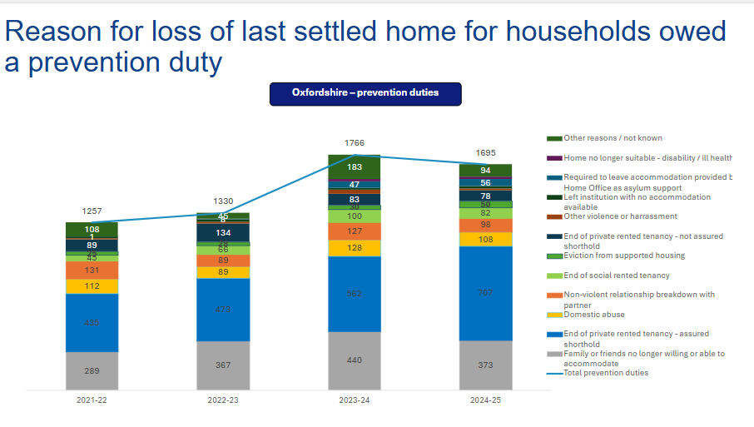ii.

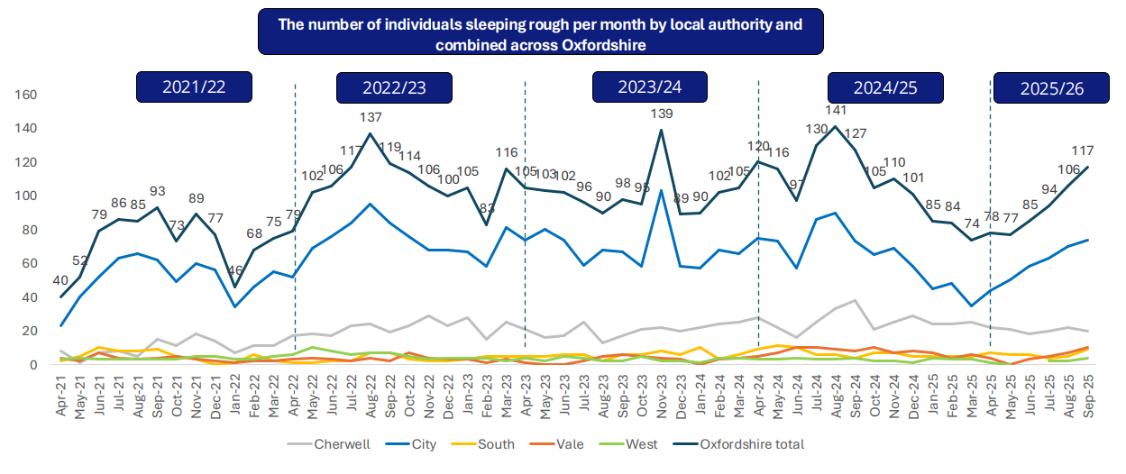
iii.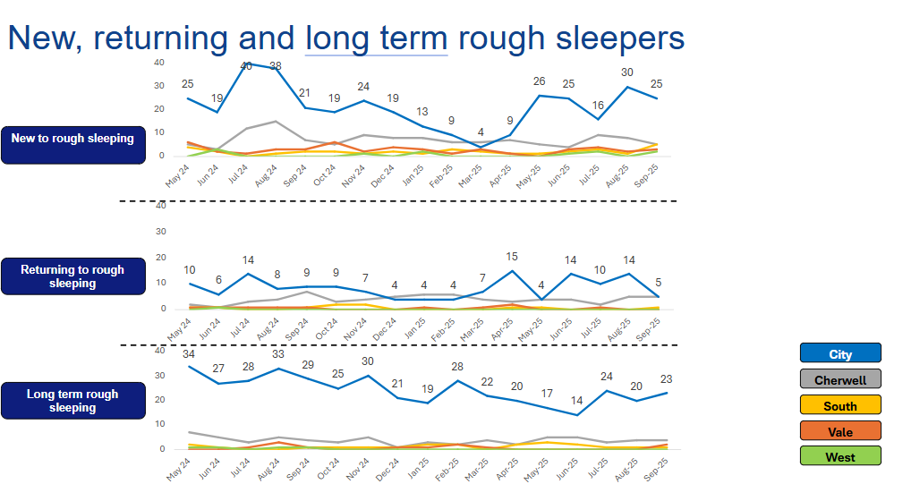

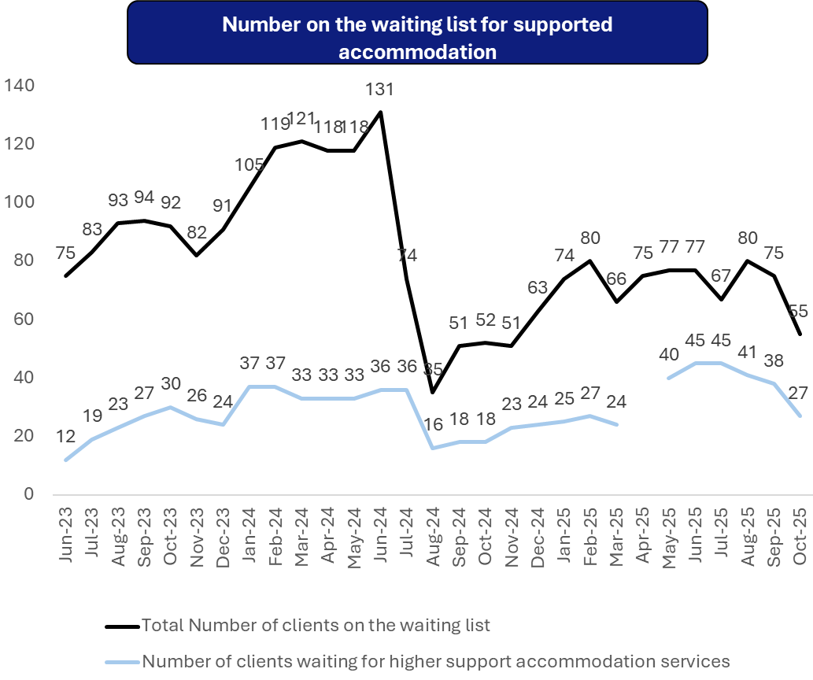
iv.
Glossary

Homeless Mortality Reviews: Reviews carried out after someone who was homeless dies. They look at what support was involved, what went wrong, and what services could do better to keep people safe in the future.

Housing Allocation Policy: The rules a council uses to decide who can join the housing register and how social housing is offered. It explains who gets priority and how homes are allocated.

Long-term rough sleeping: Long-term rough sleeping means someone has been seen rough sleeping recently and has also been seen on at least three separate months over the past year.

Move-On: When someone leaves supported or temporary accommodation and moves into a more permanent home, such as social housing or private rented housing.

Multidisciplinary Approach: Different services work together to support one person for example, housing teams, health staff, mental health workers, drug and alcohol services, and social care. The aim is to give joined-up support that meets the individual’s needs in one coordinated way.

Multiple and complex needs: Individuals experiencing a combination of three or more severe, overlapping issues, typically homelessness, substance misuse, mental health difficulties, domestic abuse, and offending, resulting in poverty, stigma, discrimination, becoming ill earlier in life and dying sooner than expected.

Oxfordshire Homelessness Alliance: A group of homelessness organisations in Oxfordshire that work together to provide outreach, support, accommodation, and prevention services. The Alliance is jointly commissioned by Oxford City Council, the four district councils, the Buckinghamshire, Oxfordshire and Berkshire West Integrated Care Board (BOB ICB), and Oxfordshire County Council.
Alliance providers include:
• A2Dominion
• Aspire Oxfordshire
• Connection Support
• Elmore Community Services
• Homeless Oxfordshire
• St Mungo’s

Outreach: Workers who go out into the community and meet people sleeping rough, offering support, advice, and help with housing.

Person-Centred Approach: is a way of providing care, support, or services that places the individual at the heart of all decision-making. It focuses on treating people with dignity, compassion, and respect while tailoring support to their specific needs, values, and preferences.

Prevention: The homelessness prevention duty requires UK local authorities to take reasonable steps for 56 days to help eligible households avoid becoming homeless when they are at risk within that time.

Registered Provider: A person, partnership, or organisation officially registered to carry out regulated activities or provide social housing, accountable for compliance, quality, and management of services. Being registered means they are legally allowed to provide these services and must meet certain standards to keep people safe and well supported.

Rough Sleeping: The most visible form of homelessness, where someone sleeps outside or in places not designed for living—such as streets, parks, tents, stairwells, sheds, or cars.

Somewhere safe to stay: Somewhere Safe to Stay (SStS) hubs provide immediate, short-term emergency accommodation for people sleeping rough or at risk of homelessness.

Strengths-based approach: A way of working that explores an individual's strengths, abilities and their circumstances rather than their deficits, illnesses, or disabilities (or in other words, what they can't do).

Supported Accommodation: A place to live with help from staff. For people experiencing homelessness, this might be a hostel or short-term shared housing.

Temporary Accommodation: Short-term housing provided by councils or organisations to individuals or families who are homeless or at risk. This can include hostels, B&Bs, privately rented homes, or refuge accommodation, while they wait for a longer-term home.

Trauma-Informed: Being trauma-informed means understanding that people’s traumatic experiences can have an impact on their behaviour, their ability to cope with life, and their mental health and wellbeing. It means enabling an environment of healing and recovery that promotes a sense of safety.
Trusted Assessment Form: A form used to gather information on the individual’s housing and support needs, among other important details.

